1. The stdout of the shell executing “sudo ./mpwebsvr” on VM1 after step b – which should show the web server on VM1 served those two URLs/clients.

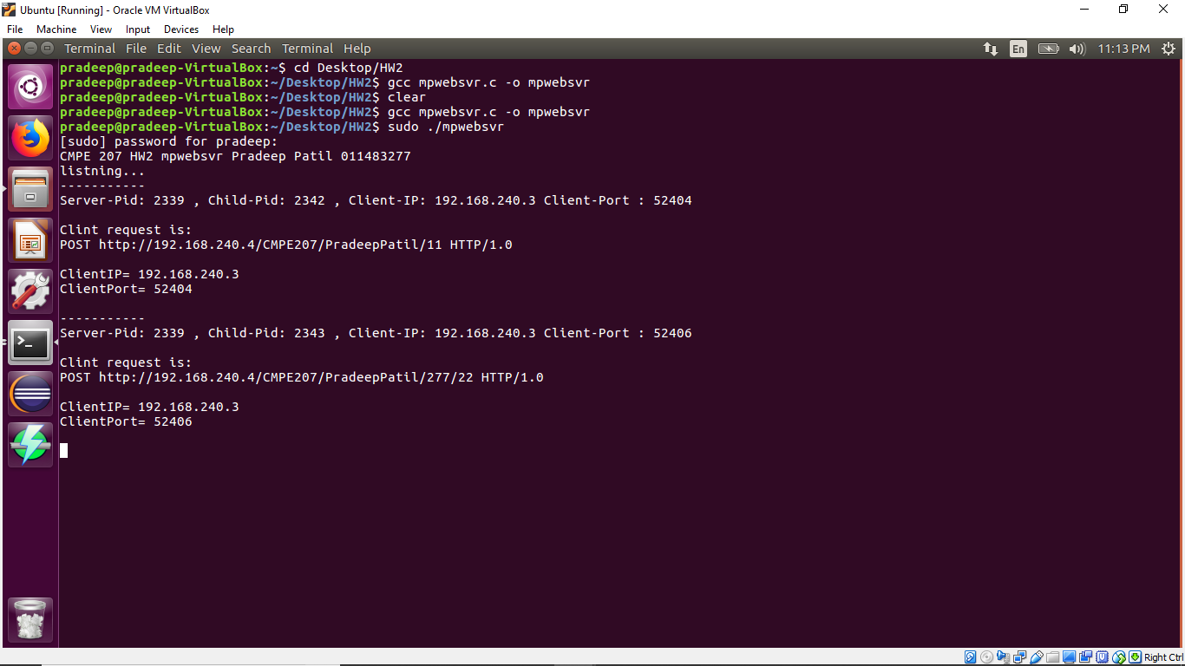

2 ) The stdout of the shell executing netstat/ps/ip on VM1 after step c – which should show http connections, multiple instances of mpwebsvr, and ip address of VM1.

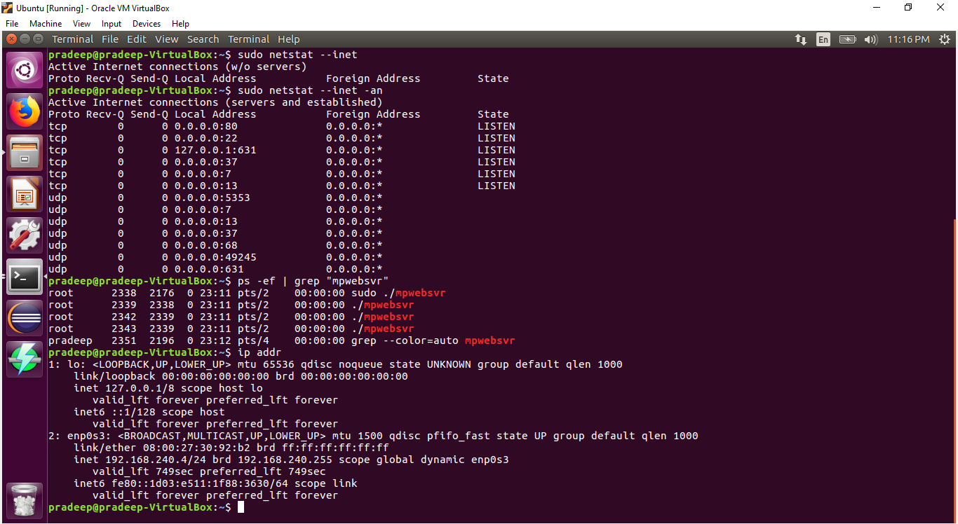

1. The stdout of both shells on VM2 after step b

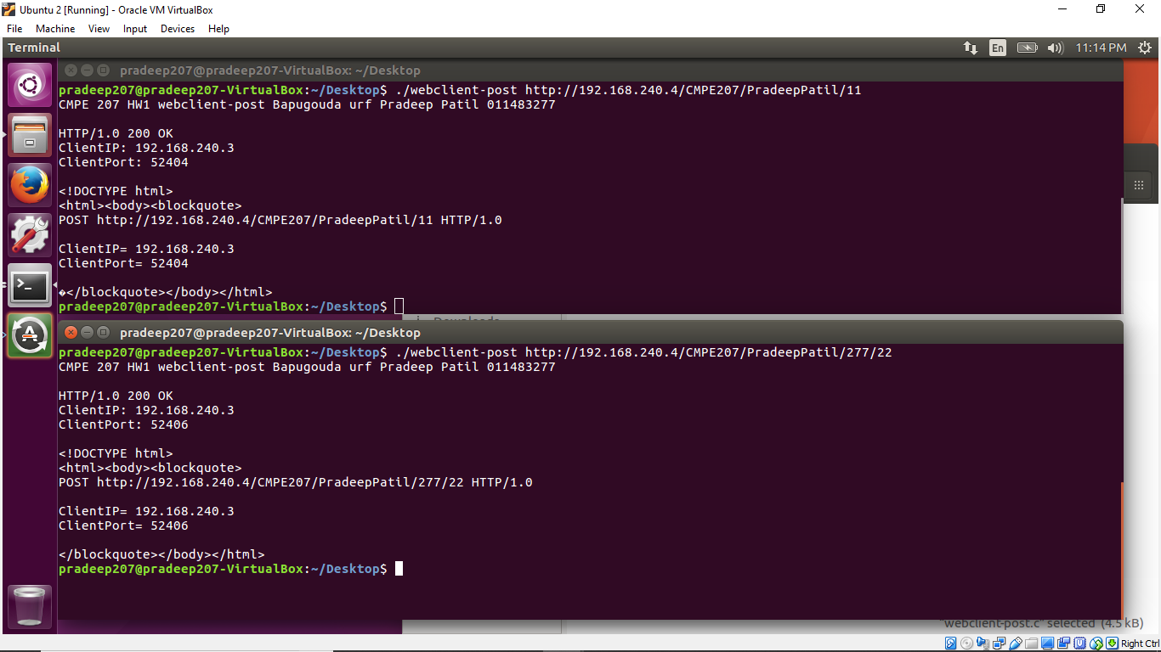

4. (10 pts) Include server-side code snippet, and describe how the server retrieves the client request via TCP which is a streaming protocol.

Answer:

//code Snippet

// Read the client request.

printf("Clint request is: \n");

while (1){

int rd;

rd = read(SockID,Buffer,sizeof(Buffer)-1);

if (rd==0)break;

strcat(ReadData,Buffer);

Buffer[rd]='\0';

printf("%s",Buffer);

//bzero(Buffer,sizeof(Buffer));

}

Description: Since TCP is streaming service we read the socket in loop until end of file. The read function returns zero when the client sends Shutdown(); indicating the end of transmission and the while loop breaks. This how how the server retrieves the client request via TCP.